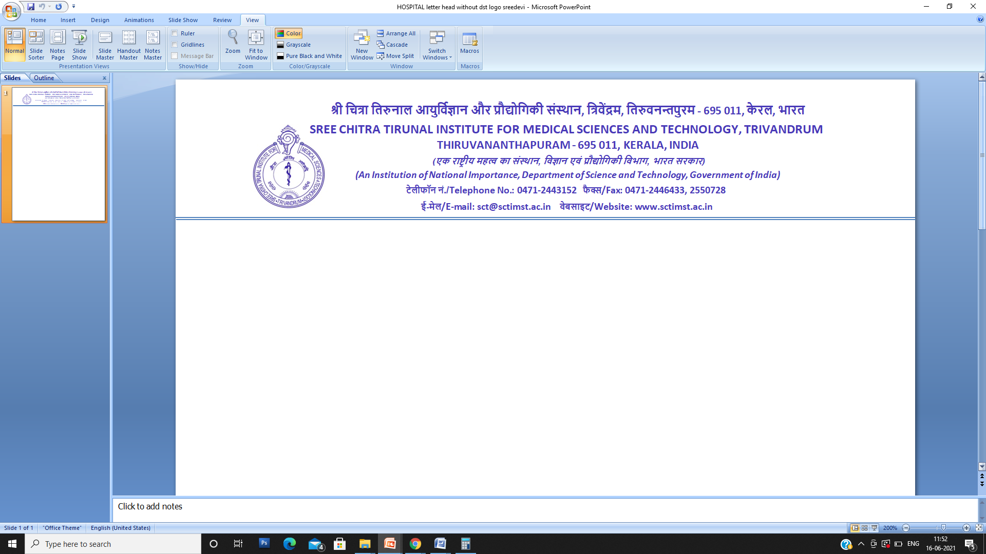

**FORM ‘F’**

**E. Code:**

[See sub-rule (1) of rule 6]

**Nomination**

To ………………………………………………………………………………………………………………………………………..................

[Give here name or description of the establishment with full address]

1. Shri/Shrimati/Kumari ………………………………………………………………………………………….. whose particulars are given in the statement below, hereby nominate the person(s) mentioned below to receive the gratuity payable after my death as also the gratuity standing to my credit in the event of my death before that amount has become payable, or having become payable has not been paid and direct that the said amount of gratuity shall be paid in proportion indicated against the names(s) of the nominee(s).
2. I hereby certify that the person(s) mentioned is a/are member(s) of my family within the meaning of clause (h) of section (2) of the Payment of Gratuity Act, 1972.
3. I hereby declare that I have no family within the meaning of clause (h) of section (2) of the said Act.
4. (a) My father/mother/parents is/are not dependent on me.

(b) My husband’s father/mother/parents is/are not dependent on my husband.

1. I have excluded my husband from my family by a notice dated to the Controlling Authority in terms of the proviso to clause (h) of section 2 of the said Act.
2. Nomination made herein invalidates my previous nomination.

**Nominee(s)**

|  |  |  |  |
| --- | --- | --- | --- |
| Name in full with full address of nominee(s) | Relationship with the employee | Age of nominee | Proportion by which the gratuity will be shared |
| 1. |  |  |  |
| 2. |  |  |  |
| 3. |  |  |  |
| so on. |  |  |  |

**Statement**

1. Name of the employee in full
2. Sex
3. Religion
4. Whether unmarried/married/widow/widower
5. Department/Branch/Section where employed
6. Post held with Ticket or Serial No., if any
7. Date of appointment
8. Permanent address

**E. Code:**

Village…………………………………. Thana…………………………..Sub-division……………….. Post Office………………

District………………………………………………………………………………………… State……………………………………………

Place Signature/Thumb impression

Date of the employee

*Declaration by witnesses*

Nomination signed/thumb impressed before me.

Name in full and full address of witnesses Signature of witnesses

1. 1.

2. 2.

Place

Date

*Certificate by the employer*

Certified that the particulars of the above nomination have been verified and recorded in this establishment.

Employer’s Reference No., if any.

Signature of the employer/

Officer authorized

Designation

Name and address of the

Date Establishment or rubber stamp

thereof.

*Acknowledgement by the employee*

Received the duplicate copy of nomination in Form ‘F’ filed by me and duly certified by the employer.

Date Signature of the employee

*Note:* Strike out the words or paragraphs not applicable.